Calorimetry Experiment

14 November 2022

Section 506

Risha Thimmancherla, Adrian Cortina, Kevin Lei

**Introduction**

We hypothesize that the ceramic coffee cup will maintain the temperature for hot liquid for the longest amount of time, due to the fact ceramic itself is a good heat insulator because of its properties.

**Results and Calculations**

***Graph 1:*** *Risha’s Data*

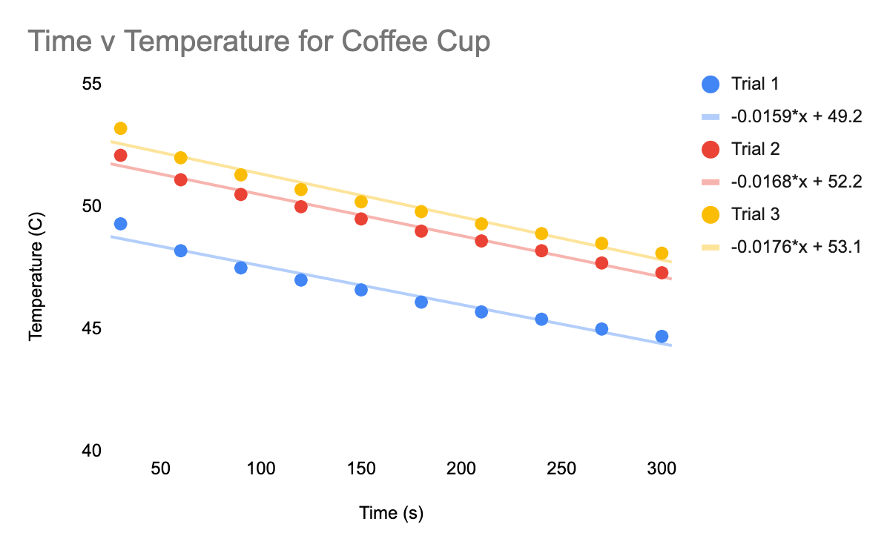

***Graph 2:*** *Adrian’s Data*

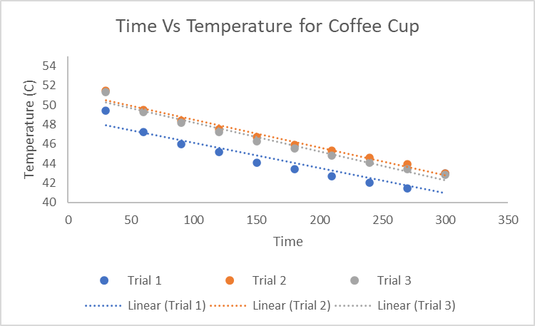  
  
***Figure 3:*** *Kevin’s Data*

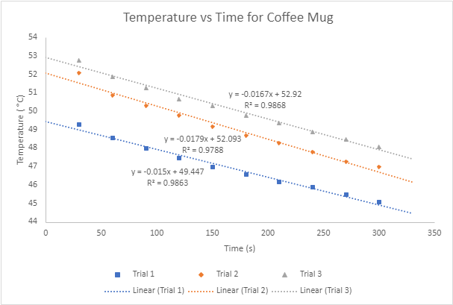

|  |  |  |  |
| --- | --- | --- | --- |
|  | **Data Set 1** | **Data Set 2** | **Data Set 3** |
| **Trial 1** |  |  |  |
| Empty Calorimeter Mass (g) | 150.78 | 381.61 | 224.27 |
| Calorimeter with cold water Mass (g) | 190.61 | 419.04 | 264.32 |
| Final Mass (g) | 237.40 | 465.82 | 311.48 |
| **Trial 2** |  |  |  |
| Empty Calorimeter Mass (g) | 150.95 | 382.21 | 224.27 |
| Calorimeter with cold water Mass (g) | 188.70 | 421.82 | 264.29 |
| Final Mass (g) | 236.03 | 468.52 | 311.16 |
| **Trial 3** |  |  |  |
| Empty Calorimeter Mass (g) | 151.04 | 382.29 | 224.27 |
| Calorimeter with cold water Mass (g) | 189.99 | 423.01 | 265.02 |
| Final Mass (g) | 238.51 | 470.15 | 312.29 |

**Table 1:** Mass of calorimeter when empty, filled with cold water, and at the end of the experiment

*Calculating Ccal*

Using Data Set 1’s Trial 1 as an example:

To calculate the heat absorbed by the cold water, the formula *q = mc∆T* was used. To determine mass, the mass of the calorimeter was subtracted from the mass of the apparatus with cold water added, yielding *39.83 g*. The change in temperature was *27.9 ˚C*. Thus, *qcold water = 4.649 * 10^3 J.*

To calculate the heat released by the hot water, the same formula was used, except with a mass of *46.79 g* (final mass - mass with cold water) and a temperature change of *-50.8 ˚C* (the final temperature - boiling point). Thus, *qhot water = -9.945* 10^3 J.*

When this was plugged into the equation *qhot water = - (qCal + qcold water)*, resulting in *qCal = 5296 J*.

As *qcal = Ccal * ∆T*, where *∆T = 27.9*, we can calculate the *qCal* to be *189.8 J/˚C.*

*Calculating the Average Ccal and Standard Deviation for All Three Trials*

To calculate the average *Ccal,* the three C*cal* values were summed together and divided by three. The result was *174.6 J/˚C* for Data Set 1.

To calculate the standard deviation, the three values were entered into an excel spreadsheet. Using the spreadsheet, the standard deviation for Data Set 1 was calculated to be *14.10 J/˚C.*

|  |  |  |  |
| --- | --- | --- | --- |
|  | **Data Set 1** | **Data Set 2** | **Data Set 3** |
| Average Ccal (J/˚C) | 174.6 | 205 | 171.6 |
| Standard Deviation (J/˚C) | 14.10 | 12.70 | 11.21 |

**Table 2:** Average calorimeter constants for the three data sets and their standard deviations

**Analysis and Conclusions**

When we observe the Average Ccal for all three Data Sets, it can be seen that the Ccal for Data Set 2 is higher than the other two. Since Ccal tells us the amount of energy required to raise the temperature of the calorimeter by one degree, it can be interpreted that the calorimeter from Data Set 2 requires more energy for its temperature to be raised than the other two Data Sets’ calorimeters. Thus, the Calorimeter from Data Set 2, which was the ceramic coffee cup, may maintain the temperature of the hot liquid for the longest amount of time.